Math Circle Problem Set 1. Name:

Represent the numbers 3, 6, 9, and 10 each as figurate numbers in more than one way.

Draw 1-by-1, 2-by-2, 3-by-3, 4-by-4, and 5-by-5 squares and count the number of tiles in each of them. Compute the number of tiles in a 20-by-20 square.
Find the sum or the difference for the pictures inside the red squares.

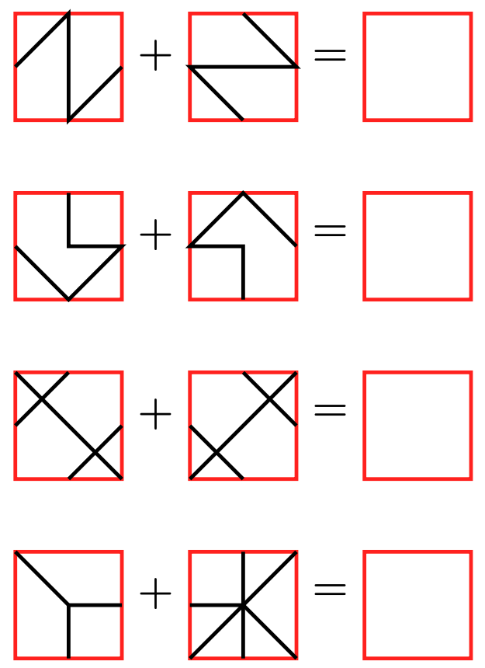 | 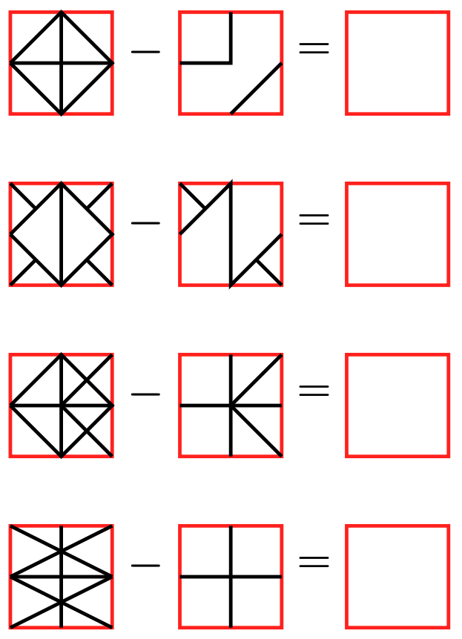

Compute 2¹, 2², 2³, 2⁴, 2⁵. What do you think 2⁰ should be? What do you think 2⁻¹ should be?

Draw and compute the differences (in whole tiles) between 1x1 and 2x2 squares; between 2x2 and 3x3 squares; and between 3x3 and 4x4 squares.

Miles computed the the sums 1+3, 1+3+5, and 1+3+5+7 by arranging tiles into squares. He matched the colors of the tiles to the colors of the numbers. Reproduce his pictures. Compute 1+3+5+7+9+11+13 using Miles’s approach.
Find the missing number. How many odd numbers are in the sum 1 + 3 + 5 + 7 + ... + ? + ?? = 11 x 11? Find the missing numbers: ? and ??. Using the fact that 10 x 10 = 100, calculate the sum (without multiplying 11 by 11 and without adding all odd numbers).

Calculate 12 x 12 without multiplication.
What square should Miles draw for the sum 1+3+5+...+99?

How many green triangular tiles with 1-inch sides should be used to tile a red triangle with 2-inch sides? A blue triangle with 3-inch sides? A purple triangle with 4-inch sides? Find the pattern. Will the pattern continue forever?
